PTP and the Mentor RG

08/02/19
Issue 1.0

Date | Issue | Summary of Changes | Updated by
8/2/19 | 1.0 | Created | Tom S

What is PTP?

The Precision Time Protocol (PTP) is a protocol used to synchronize clocks throughout an IP based computer or broadcast network. On a local area network, it achieves clock accuracy in the sub-microsecond range, making it suitable for measurement and control systems. Mentor RG is fully compliant with IEEE 1588-2008 also known as PTP Version 2. Note that PTP Version 2 is not backwards compatible with Version 1, hence Version 1 is not actively supported.
It is defined as a method for distributing time over a network, with a single network time server providing the source of time, to synchronize one or more Slaves. The server
periodically transmits Sync and Follow-up messages, which the slaves use to derive the time.

The PTP network time server is generally referred to as a PTP Grandmaster, with a device that derives its timing synchronization from PTP being referred to as a PTP Slave.
A Master is a device that provides the time in a given PTP domain and a Slave is a device that synchronizes to a Master. A Grandmaster is a Master that is providing the ultimate source of clock synchronization in a network.

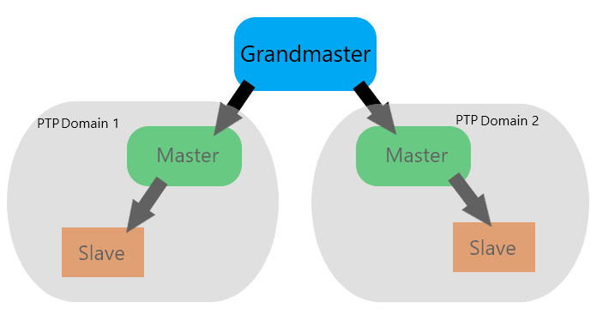

Within a PTP domain there are several message types used to establish the time within that network:
Announce messages are used to establish the synchronization hierarchy and to provide the clock status and clock criteria used to determine which clock acts as the Grandmaster.
Sync and Follow-up messages are transmitted by the Grandmaster and are used by Slaves to derive the time.
Delay Request messages are a request for timing information. They are sent from the Slave to the Grandmaster to determine the reverse path propagation delay between the Slave and the Grandmaster.
Delay Response messages are sent by the Grandmaster and contains the time of receipt of the Delay Request message at the Grandmaster.

Role of the Mentor RG in a PTP System

The Mentor RG will most commonly take the role of a Master in a PTP environment. It can also use GPS as its own time/sync source, offering the ability to act as Grandmaster.
A standard install will have two RGs (main & reserve), with the reserve set to a lower PTP priority. Both units will be Grandmaster capable, but the reserve unit will only act as the systems Grandmaster if the main unit fails. This ‘fail over’ is possible due to the Best Master Clock Algorithm (BMCA).

The BMCA allows the most accurate Master to automatically take over as Grandmaster when the previous Grandmaster loses its GPS lock, gets disconnected from the network, or is unable to act as Grandmaster for any reason.

The BMCA runs on all clock devices in a network and uses several criteria to determine which Master should be Grandmaster.
These are listed below in priority order:
1. User Definable Priority 1 Field (the lowest value <= 128 wins)
2. Clock Class (e.g. GPS vs free running)
3. Clock Accuracy
4. Clock Variance (jitter and wander)
5. User Definable Priority 2 Field (the lowest value <= 128 wins)
6. Clock Source Port ID (usually the Ethernet MAC Address)

To establish an automatic main and backup Grandmaster fail over, the Priority 2 field is used to identify main and backup clocks between two or more otherwise identical redundant Grandmasters.
eg:
• Main Grandmaster (Priority Field 1 = 128; Priority Field 2 = 127)
• Backup Grandmaster (Priority Field 1 =128; Priority Field 2 = 128)
If both identical Master devices are locked to GPS, they will have the same clock quality, so the lowest Priority Two Field value will select which is the Grandmaster. If the Main clock loses GPS lock, then the Backup clock becomes the Better Master and will take over as Grandmaster.

It should be noted that if any GPS synchronized Master loses GPS lock, it will free run and be reliant upon its own internal oscillator. However good this oscillator is, over an extended period it will drift relative to the GPS clock. Once GPS lock is re-acquired, unless the Master’s local oscillator phase-lock loop (PLL) is driven slowly to re-synchronize with the GPS clock, the system can suffer from “Sync Shock” when the Master’s clock frequency suddenly changes. This is undesirable in most applications, especially video/audio production. The Mentor RG will always slow lock on a re-acquisition of GPS lock.

Definitions & Settings

GPS
In almost all cases, the Mentor RG in a PTP environment will be fitted with a GPS option card. This will allow the RG to lock to GPS/GLONASS satellites for its timing/sync information.
Some important settings in relation to the GPS configuration on the RG are listed below:

Lock Mode – Within the Lock menus, the ‘Mode’ setting must be set to ‘Internal Freerun’ when using GPS
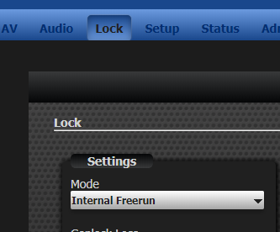

Antenna Type – Within the GPS Option menu, the antenna type must be set to match the antenna connected to the RG.
If using the basic RF type antenna that connects via the BNC socket, it should be set to ‘Basic’.
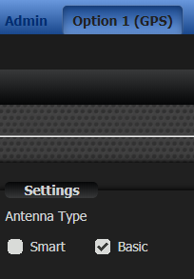

If using the smart Acutime 360 Trimble antenna that connects via the multi-pin LEMO socket, the mode should be set to ‘Smart’. The Acutime box should also be enabled.

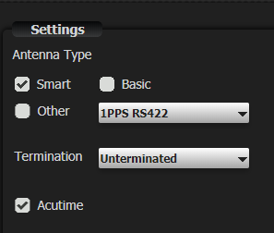

ATR Lock – This should be disabled in most cases.

The concept of ATR is covered by SMPTE document ST 2059-1, which defines the “SMPTE EPOCH”. It defines a starting point of 00:00:00 TAI (International Atomic Time) on January 1st 1970, at which time all generating equipment is deemed to be phase locked. This is the same EPOCH used in the SMPTE profile for IEEE 1588 Precision Time Protocol.
In order to make use of the ATR definition, precise date/time provided by the GPS receiver is required. This allows the current state of the Mentor RG to be computed with regard to the epoch as defined by ATR. By accurate determination of current time, any ATR equipped items may be locked together again.

This ATR Lock setting will cause the unit to fast lock to the GPS signal when enabled. This can put the system at risk of ‘Sync Shock’ and should therefore be disabled.

PTP
When using the Mentor RG for PTP, there are a number of settings that must be configured to match the system/network it is being installed into.
Many of these settings will be global throughout the system and the customer should be aware of how their PTP network is configured. This will likely need the involvement of the IT department of the site as well as the engineers directly responsible for the RG itself.

The first settings to configure are likely to be the units own network settings such as it’s IP address. It should be ensured that the unit is setup on the same network domain as the other PTP devices it will be connecting to. These options are found in the Admin-system settings menu.
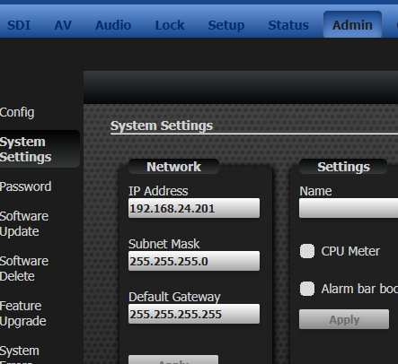

Once the unit has been setup on the network, the PTP specific settings can be configured. These are found in the setup-PTP menu section.

Profile - The Mentor RG currently offers 4 default profiles to choose from:
End-to-End
Peer-to-Peer
Media
SMPTE

Each profile loads a set of individual parameter values appropriate for that profile. The user can choose to adjust the value of each parameter within a limited range to suit his circumstances. The range of adjustment for each parameter varies according to the profile selected.

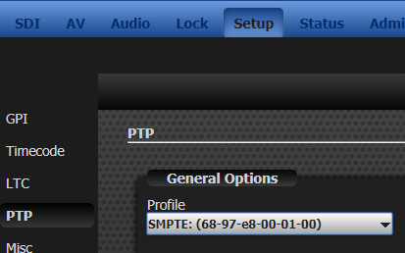

Mode - The options available here are ‘Disabled’, ‘Master’ and ‘Slave’. As previously mentioned in this document, the Mentor RG will generally be configured as a Master.

Once the Mode has been set, other options will become available.
If set as a Slave, settings relating to operation as a Master will not be visible to the user.

Domain – A domain consists of one or more PTP devices communicating with each other as defined by the protocol. Different PTP domains may be defined on the same LAN segment. Multiple PTP domains may co-exist but will not have visibility of each other. Normally only one will exist and the default domain, identifier 0, will be loaded with the selected Profile. Note that domain 127 is loaded for the SMPTE profile.

Clock Class – This determines the Class of clock for use in the BMCA. This will normally be left on the default ‘Grandmaster’ setting.

Clock Accuracy – This again categorizes the clock for use in the BNCA. This will normally be left on the default value of ‘Within 250ns’.

Time Source - This is represented in hex (as per IEEE-1588) - this information-only attribute indicates the source of time used by the grandmaster clock. It will most commonly be set to GPS.

Sync/Announce Interval – These two options allow the user to set the mean time interval between successive sync and announce messages respectively. These will normally be left to the default values set by the choice of Profile.

Two-step Sync (followup) - If enabled, the RG will transport the timestamps recorded at the master clock to the slave clock.

Priority 1 - User configurable designation that a clock belongs to an ordered set of clocks from which a master is selected.

Priority 2 - User configurable designation that provides finer grained ordering among otherwise equivalent clocks. As mentioned earlier in this document, this can be used to set up a fail over process between two Grandmasters.

Delay Mechanism – Peer-to-peer or end-to-end can be set when using the Media or SMPTE profiles. The preferred setting should be known by the customer as this will be determined by the structure of their network system.

Announce Receipt Timeout Multiplier - Specifies the number of announce intervals that must pass without receipt of an Announce message before the occurrence of the event.

Further Thoughts

In a PTP environment, timing is crucial. Therefore, every effort should be made to reduce delays in the network. Customers should be aware that PTP is unlikely to be rolled out into an existing network infrastructure without a lot of changes to hardware etc. Only network hardware certified as fully compliant with IEEE 1588-2008 should be used for the infrastructure. Other hardware may degrade timing performance.

Following on from this, it is worth noting the different types of clock within a PTP infrastructure:
Ordinary Clocks are those devices that are at either end of a network and are not switches or routers.
A Slave Only clock never acts as a master, whereas a Master/Slave clock can act as either and a Preferred Grandmaster is configured to never become slave.

It is vital that switches and routers in any IP video network that relies upon PTP for synchronization are “PTP Aware”, meaning they can account for their own queuing delay, to ensure downstream timing accuracy. This can be achieved in one of two ways.
The first is by the switch acting as a Transparent Clock which hardware time stamps Sync and Delay Request messages on arrival and departure and adds the difference to a correction field in the message.
The second way is to act as a Boundary Clock, which receives time from a Master on one slave port and provides one or more Master (not Grandmaster) ports to downstream Slaves in a PTP Domain.
