On the new EHX v8.5.2 release ISO, there is no EHX standalone client.

Please direct customers to use the combined EHXPM installer

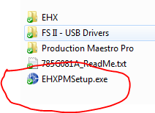

\*\*\*Note on some PCs it will ask that the customer install the .NET application. For some users once they have installed .NET , they might need to reboot their PC and then do the EHX install

Goto control panel > select Program and features

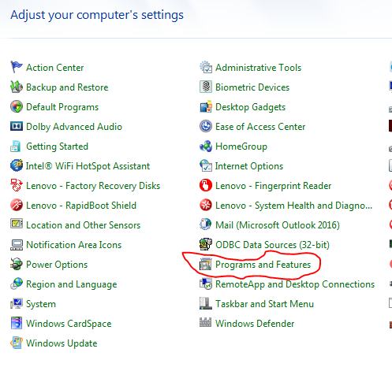

Select Turn Windows features On/OFF > turn on > .NET

