SIP Dialing from a V-Series Panel
Prerequisites;
- Set Up SIP accounts in Gateway and assign 4- wire ports.
- Assign Eclipse port as a Tel-14.
- Turn Off hardware detect on port.

Navigate to SIP Directory in Gateway Software
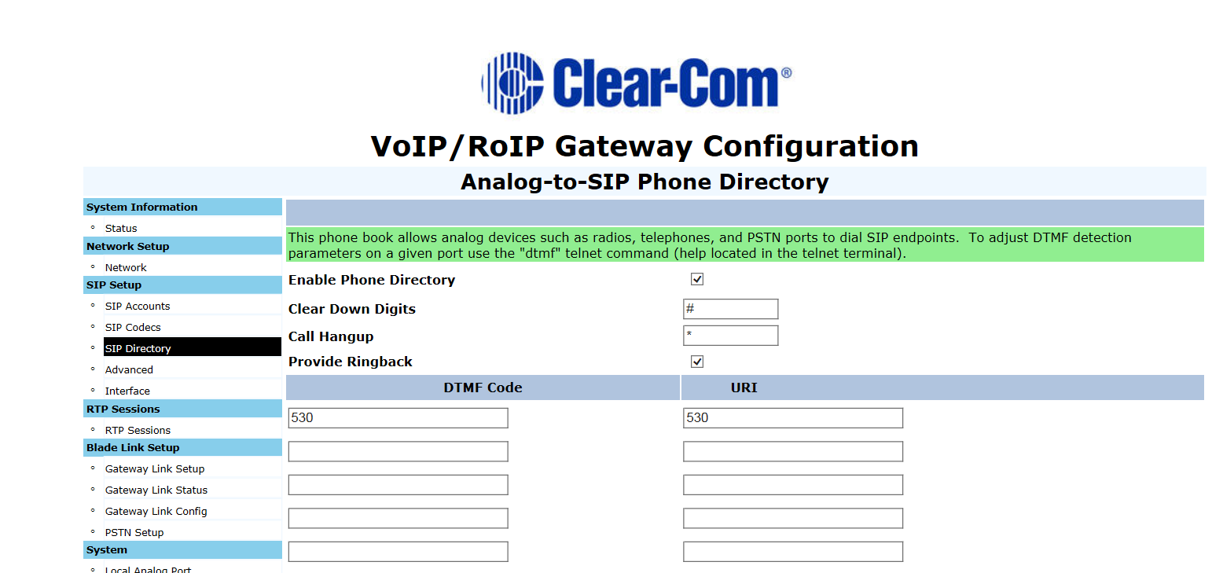

You must set up SIP directory to make outbound calls.
- Check enable Phone Directory.
- Enter # in Clear Down Digits box
- Enter * in Call Hangup box
- Check provide Ringback
Create a SIP Phone Directory for the SIP extensions you want to dial.
In order to make an out bound call you must first set up each SIP end point/extension you would like to call and associate a DTMF Code with a URI.
- DTMF Code= a numeric number equivalent of the URI.
- URI (Uniform Resource Identifier) is a string of characters used to identify a resource.
- For outside calling you will need to know what DTMF digit is associated with outside dialing. Dialing 9 or 0 for example will get you outside dial tone. Than you can dial your number.
- The SIP URI is the SIP address assign to a specific extension or port
- You must enter all the SIP extensions that you wish to dial up to a maximum of 24.
Dialing from a V-Series Panel
Once you have setup your SIP Directory you can now use the DTMF pad on a V-Series panel to make calls.
From a panel:
  - Press 1 – to enable DTMF
  - Press # (Clear down digit), this tells the gateway to be ready for DTMF
  - Enter DTMF
  - Press * to hang up (Hangup digit)

