Eclipse-HX matrix system overview using Gateway (CG-X4-MIP1-M4W3.)

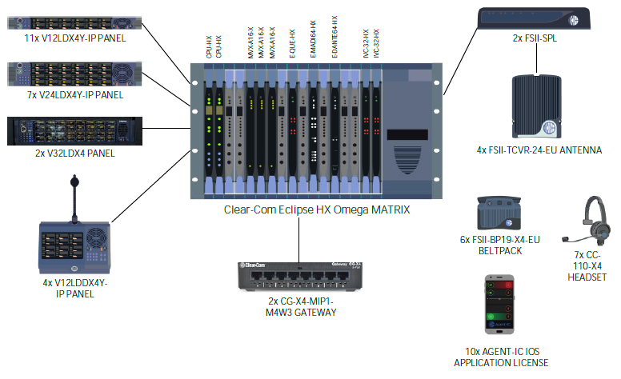

Gateway wiring (CG-X4-MIP1-M4W3.)
