Resetting Gateway VoIP Module to Factory Settings

To completely clear the memory of a Gateway VOIP module, you’ll need to access the board inside and move jumper to reset.

1. Make sure power to the gateway is disconnected.

2. Remove the lid.

3. Locate the three pins at the back of the board, closest to the power input. (See figure 1.)

4. Using the jumper short together the pin labeled erase with the center pin.

5. Connect the power to the Gateway and keep the pins shorted.

6. Once the Gateway is powered on, all the LED lights on the front of the Gateway will briefly flash on and off. After approximately five seconds, the LED lights will come on again and remain on.

7. Power down the Gateway and move the jumper back to the normal position.

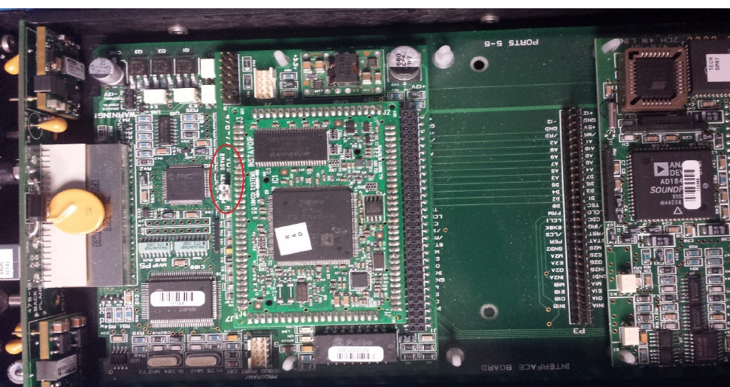
figure 1

