How to Make RJ45 crossover adaptors
Pinouts
Matrix X-Over (with the TX/RX data lines looped together)
Connector 1 | Connector 2
Pin 1 (Matrix RX Data +ve) | Pin 7
Pin 2 (Matrix RX Data -ve) | Pin 8
Pin 3 (Matrix Audio RX +ve) | Pin 4
Pin 4(Matrix Audio TX +ve) | Pin 3
Pin 5(Matrix Audio TX -ve) | Pin 6
Pin 6 (Matrix Audio RX -ve) | Pin 5
Pin 7 (Matrix TX Data +ve) | Pin 1
Pin 8 (Matrix TX Data -ve) | Pin 2
Screen | Screen

Audio X-Over (without the TX/RX data lines looped together)
Connector 1 | Connector 2
Pin 1 (Matrix RX Data +ve) | No Connection
Pin 2 (Matrix RX Data -ve) | No Connection
Pin 3 (Matrix Audio RX +ve) | Pin 4
Pin 4(Matrix Audio TX +ve) | Pin 3
Pin 5(Matrix Audio TX -ve) | Pin 6
Pin 6 (Matrix Audio RX -ve) | Pin 5
Pin 7 (Matrix TX Data +ve) | No Connection
Pin 8 (Matrix TX Data -ve) | No Connection
Screen | Screen

E1 X-Over (when link EQUE card E1/T1 back to back or some 3rd party devices)
Connector 1 | Connector 2
Pin 1 (Data TX +ve) | Pin 4
Pin 2(Data TX -ve) | Pin 5
Pin 3 | No Connection
Pin 4(Data RX +ve) | Pin 1
Pin 5(Data RX -ve) | Pin 2
Pin 6 | No Connection
Pin 7 | No Connection
Pin 8 | No Connection
Screen | Screen

Construction
The construction process is identical for all three types:
- Take two PCB Mount RJ45 connectors
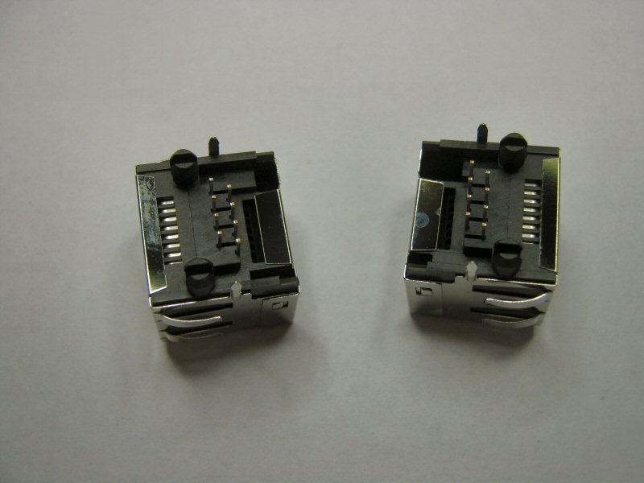
- Carefully align back to back and clamp in a vice
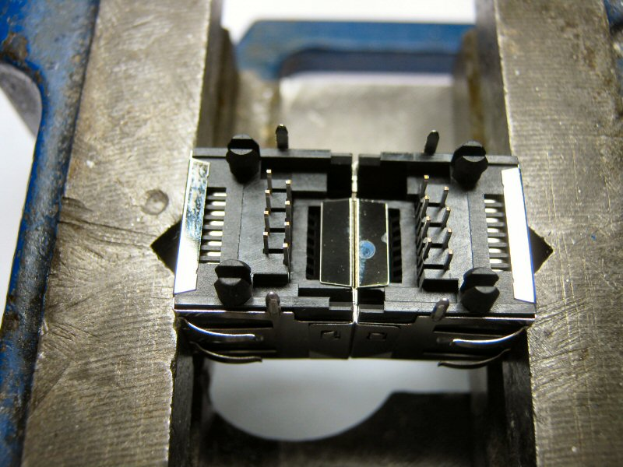

- Solder the shields together on all four sides
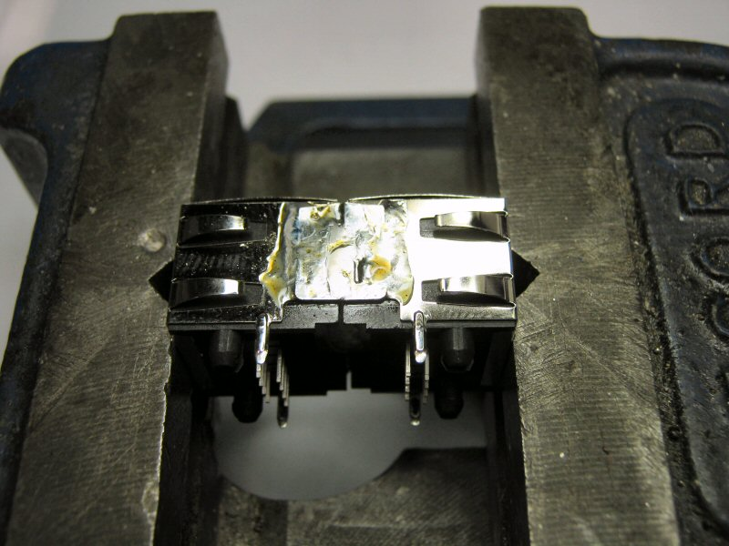
- Trim off the PCB mounting lugs and wire the connectors according to the appropriate table
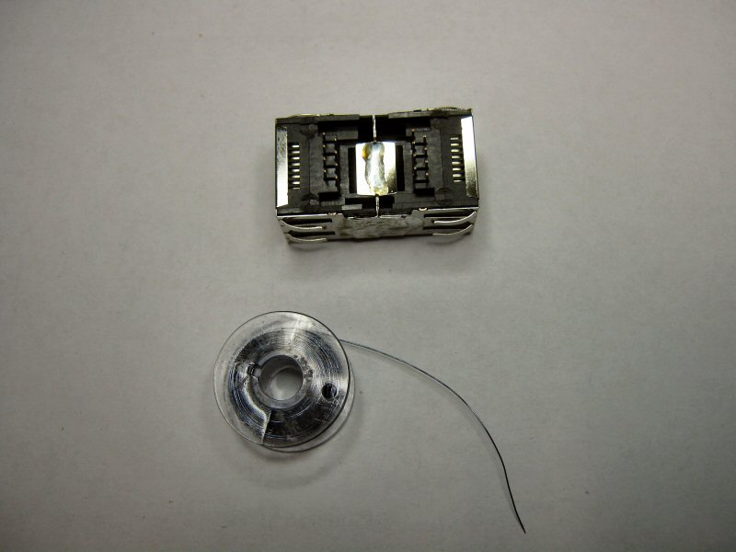

- After wiring trim the legs
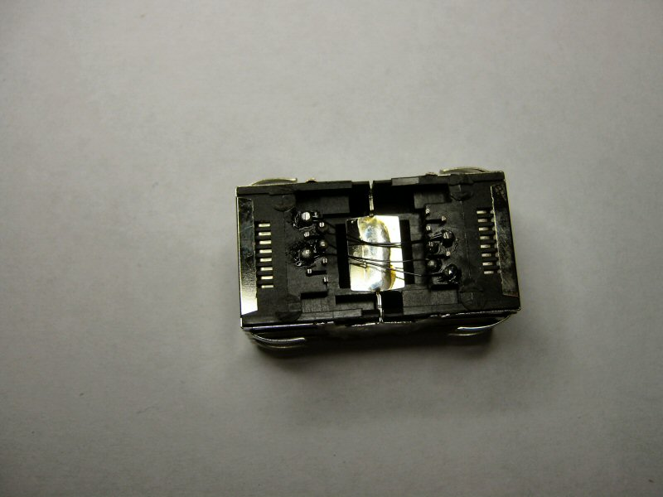
6. Cover in Heat Shrink, trim to a neat finish and apply the appropriate label
