**PASSCODE REQUEST FORM**

Dear Customer

Thank you for purchasing Clear-Com. To supply you with your matrix product license please complete the form below

**Information that we need to generate your passcode:**

Clear-Com Sales order #:

(If S.O.# is unavailable) Customer Name:

(If S.O.# is unavailable) Customer PO#:

Passcode Type Requested) Clear-Com part number:

If requesting a **Production Maestro (Pro or Site)** license please provide the

Matrix Dongle / ID:

If requesting an **Agent IC** license please provide the

Matrix Dongle / ID:

If this new license request is an add-on to a current license please also provide the

Current passcode info

You can find your matrix ID label located behind the Eclipse Omega/ Median PSU door or stuck on the side/ underneath of your Eclipse Delta / Pico matrix

You can find your existing current passcode in ECS / EHX

Configuration > Preferences >System access codes

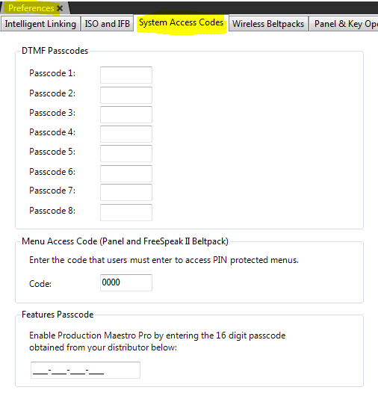

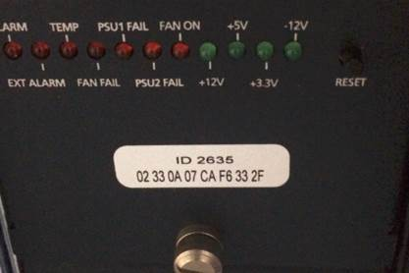

Please email the completed form to Clear-Com <inset email >

For a Concert license there is a separate Concert License Request Form, however, in addition to the SO# we will need the serial number of the concert server.

**Thank you**